**Professor Krassanai Wangrangsimakul**

BSc (Medical Science),DDS, FFDRCS (Ireland),FIAOMS,FRCDS(Thailand),

Diplomat Oral & Maxillo-facial Surgery,

22/01/2016

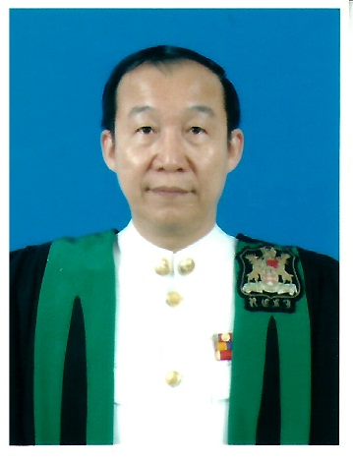

BIOSKETCH

Professor Krassanai Wangrangsimakul is a specialist Oral and Maxillo-facial Surgeon registered under the Dental Council and the Royal College of Dental Surgeons of Thailand .He got the BSc.in Medical Science from University of Medicine which later became Mahidol University in 1973 and Doctor of Dental Surgery from Chulalongkorn University in1975.He was awarded American Field Service International Scholarship to study in Lexington Senior High School, North Carolina, USA during 1967-1968 and was selected as Member of the US National Honor Society. After his graduation from the university he worked as a Dental Surgeon at Manorom Christian Hospital in Central Thailand during 1975-1978.

During 1978-1980 he was offered a training post in Oral and Maxillo-facial Surgery at the Northern Ireland Plastic and Maxillo-facial Unit, the Ulster Hospital, Belfast, UK under the National Health Service. He passed his Primary FDSRCP&S from the Royal College of Physicians and Surgeons, Glasgow, Scotland and got his Fellowship in Oral Surgery (FFDRCS) from the Royal College of Surgeons in Dublin, Ireland in 1980.He also got his Diploma from All Nations Christian College, Hertfordshire, UK in 1981.

Later he was offered a teaching post at the Department of Oral and Maxillo-facial Surgery ,Faculty of Dentistry, Chulalongkorn University ,Bangkok in 1981-1983 .He was invited to help setting up a first new Dental School in the south of Thailand at the Prince of Songkla University where he was Vice-Dean,Founding Heads of the Department of Oral and Maxillo-facial Surgery and Department of Oral Biology and later became Dean of the Faculty of Dentistry.

He designed and set up the first Dental Hospital in Thailand at the Prince of Songkla University .He was the first surgeon introducing Branemark Osseo-integration Implant and performed the first Osseo-integration fixed bridge of the mandible in Thailand. Beside starting implant surgery, since he was Vice Dean of Academic Affairs he had the responsibility for Curriculum development. So he had a special interest in Medical Education and went to attend a course in Medical Education at the University of Dundee in 1988 under the British Council scholarship. He also invited Professor Ronald Harden and team to run a workshop on medical education and OSCE at the Prince of Songkla University for medical and dental educators from all over Thailand. Professor Krassanai not only helped starting the Dental Faculty at the Prince of Songkla University,he also helped starting and teaching at the Faculty of Dentistry,University of Sains Malaysia,Malaysia ,Suranaree University of Technology, and Maefahleung University,Thailand.

He has been invited as External Examiner for many Universities e.g. National University of Singapore, University of Malaya, University of Sains Malaysia, AIMST (Asia International Medical Sciences and Technology University),Malaysia and University Kebangsaan Malaysia. External Examiner for PhD thesis ,University of Malaya.

He was one of the founding members of many National and Regional Professional Organizations. He was the Founding Memberof the Examination and Certifying Board in Oral and Maxillofacial Surgery, the Dental Council of Thailand,FoundingMember of the Dental Council of Thailand by National Election, Founding Secretary General of the College of Dental Surgeons of Thailand. He was elected Vice President of the College of Dental Surgeons of Thailand and later as Vice President of the Royal College of Dental Surgeons of Thailand. He was elected Vice President of Continuing Dental Education Centre, the Dental Council of Thailand .He also help starting a Dental School at the Institute of Medicine, Suranaree University of Technology and teaching medical students for many years at the Faculty of Medicine, Walailak University in south of Thailand. He was invited to serve for the National Accident Prevention Committee of Southern Thailand and on the Advisory Board for Staff Development Unit, Prince of Songkla University.

He has been active serving with many Regional and International Professional Organizations .He was the Director of the Split-site PhD Programme between University of Manchester, UK and the Prince of Songkla University. Before he was elected President of the South East Asia Association for Dental Education (SEAADE) during 2002-2004. 1997-2000,he was one of the founding members of the Association. He served as Honorary Treasurer during 1995- 1997, Honorary Secretary, Councillor, Ex-Officio in the SEAADE Council. He has also served in the Peer Review & Consultation Programme of the South East Association for Dental Education.

He was in the International Steering Committee and Chairman of the Local Organizing Committee,5thWorld Workshop Oral health and Disease in AIDS,6-10 July 2004,Phuket,Thailand and was invited adviser to the World Health Organization. He was a Council Member of the Asian Association of Oral and Maxillofacial Surgeons and on the Board of Directors of Asian Oral Implant Academy.

Currently, he has been invited as visiting lecturer and advisor to the Faculty of Odonto Stomatology, University of Medicine and Pharmacy,Ho Chi MinhCity,Vietnam,President of Chulalongkorn University Alumni,Songkhla and

Advisor to the Mayor of HatYai, Thailand.